***SECTION 23: STUD BEEF CATTLE***

**Saturday 6th March 2021**

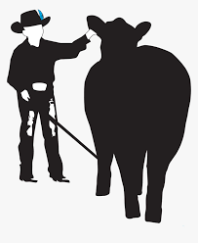

* Grass Show Ring Outside.
* Loads of Prizes & Trophy’s.
* Interbreed Calf Champion.
* Best Local Exhibit.
* Junior Beef Paraders.

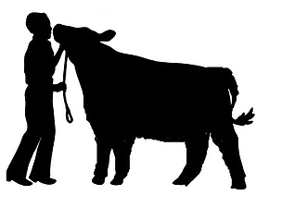

***...***

Beef Cattle Coordinator: Tim Light. 0458 744 552

Beef Cattle Secretary: Briony Looker. 0488 527 949

Email: [doublel_fitting@yahoo.com.au](mailto:doublel_fitting@yahoo.com.au)

**Stud Beef Cattle Conditions of Entry:**

1. **EACH BREED MUST BE ON A SEPERATE ENTRY FORM**
2. **Calves less than twelve months exhibited as a calf at foot cannot be exhibited in the under twelve month’s class**.
3. Entry fee $10 per animal (includes bedding and breast plate)
4. **ALL LATE ENTRIES, RECIEVED AFTER THE 1st March 2021, WILL HAVE TO PAY A $10 LATE ENTRY FEE FOR EACH HEAD THE EXHIBITOR WISHES TO ENTER.**
5. **Entries close 26th February 2021.**
6. Exhibits must be registered in respective breed society herd book.
7. **Stud grooms must wear the** **approved breed uniform**.
8. All ages to be taken from the 1st March 2021. Calves at foot to be less than nine months.
9. **Exhibits can only compete in one general class.**
10. All male cattle over 12 months must have a nose ring. All females and males, 9 months and under 12 months to be paraded with a nose dog.
11. Neck straps are compulsory whenever cattle are in the stall.
12. Stewards reserve the right to alter classes if insufficient cattle are entered.
13. National cattle Vendor Declaration is to be accompanied with a completed National Cattle Health Declaration.
14. ***STALLING WILL BE DONE IN BREEDS & HERD STATUS. STUDS WHO HAVE SEVERAL BREEDS, CAN REQUEST ON ENTRIES THAT THE BREEDS BE STALLED NEXT TO ONE ANOTHER*.**
15. Ribbons will be awarded to third place at the discretion of the judge.
16. **STUDS AND EXHIBITORS THAT HAVE NOT PAID BY SATURDAY, WILL HAVE ALL WINNINGS WITHHELD UNTIL ENTRY FEES ARE PAID!**
17. Only cattle paraded in general classes may be entered in the group classes.
18. Appeal against a judge’s decision shall be in writing, submitted within one hour of the decision, and accompanied by a deposit of $50 which shall be forfeited to the Society if the Committee considers the appeal to be frivolous. The appeal will be considered and decided by the Committee appointed for the purpose, as soon as circumstances permit. Should any exhibit to which a prize has been awarded be disqualified, the next on the list does not necessarily obtain the prize. The committee will decide.
19. **Paraders must be aged over the age of 15 years to lead bulls, unless the Handler is deemed capable by the Chief steward.**

**\*\*\*MEMBERS OF THE ARMIDALE SHOW SOCIETY, RECEIVE HALF PRICE ENTRIES. \*\*\***

**$10 Entry Fee per Head.**

**$10 Camping Fee per Truck.**

**$20 Cleaning Fee per Stud. (Refundable On Inspection)**

**IMPORTANT INFORMATION BELOW:**

**Please note due to a COVID Safe show we have limited the entry and exit times that you can access the Showground.**

**Entry & Exit will be via the Canambe Street gate.**

**Gate Entry Times:**

**Friday March 5th from 2:00pm – 6:00pm**

**Saturday March 6th from 7:00am – 5:00pm**

**Upon entering the grounds you MUST check-in to comply with COVID Restrictions.**

**Timetable of Events:**

**Stud Beef Cattle Classes: 8:30am**

**(Judging will be Alphabetical order pending entries)**

**Stud Beef Junior Paraders: 12.30pm**

**Interbreed Group Classes: 2pm**

**Cattle Breed Classes:**

**$10 Entry Fee per Head**

|  |  |  |  |
| --- | --- | --- | --- |
| **Male Classes** | | **Female Classes** | |
| **1** | Bull 9 to 12 months | **7** | Female 9 to 12 months |
| **2** | Bull 12 to 16 months | **8** | Female 12 to 16 months |
| **3** | Bull 16 to 20 months | **9** | Female 16 to 20 months |
| **Junior & Reserve Junior Champion Male** | | **Junior & Reserve Junior Champion Female** | |
| **4** | Bull 20 to 24 months | **10** | Female 20 to 24 months |
| **5** | Bull 24 - 30 months | **11** | Female 24 - 30 months |
| **6** | Bull over 30 months | **12** | Female over 30 months |
| **Senior & Reserve Senior Champion Male** | | **Senior & Reserve Senior Champion Female** | |
| **Grand Champion Male** | | **Grand Champion Female** | |
| **13 Led Steer or Heifer** | | | |

**Interbreed Classes:**

(ENTRY REQUIRED) $5 Per Class

* **Led Steer or Heifer**

*(Sponsored by: North Hill Vet Clinic)*

* **Pair of Females under 20 months of age**

*(Sponsored by: Hubbard Hire, Armidale)*

* **Pair of Bulls under 20 months age**

*(Sponsored by: Hubbard Hire, Armidale)*

* **Breeders Group** (3 head both sexes to be represented)

*(Sponsored by: Ray White Livestock, Armidale)*

* **Sires or Dams Progeny** - (Two head by nominated Sire/ Dam)

*(Sponsored by: Ray White Livestock, Armidale)*

* **Best Local Exhibit** - Exhibit to be Bred & Owned by exhibitor within the 2350 Postcode area.

*(Sponsored by: Glocks Automotive, Armidale)*

**Major Awards & Trophies:**

* **The Lyall & Robyn Cameron ‘Young at Heart Parader’ Trophy – will be judged during general cattle classes.**
* **Paraders Competition**

***(Sponsored by: Nutrien Ag Soloutions, Armidale)***

* **Interbreed Calf Champion: To be judged from 1st place getters from both Male & Female 9- 12 month age classes.**

***(Sponsored by: New England Freighters, Armidale)***

* **Champion Steer**

***(Sponsored by: Armitage & Buckley)***

* **Interbreed Champion Female**

***(Sponsored by: Laing + Simmons Armidale)***

* **Interbreed Champion Male**

***(Sponsored by: Laing + Simmons Armidale)***

* **Supreme Exhibit**

***(Sponsored by: Rosevalley Steel, Armidale)***

**Beef Cattle Supporters:**

* ***Terry Rhodes Bobcat Service***
* ***Kelly’s Transport***
* ***Peter Kratz Livestock***
* ***Supermoto New England***
* ***Armidale Mower & Chainsaw***



***Ed & Liz, from Ed’s Tucker Box will be back in 2021 to cater the Livestock section. If you wish to place an order please phone:***

**0414 773 003**

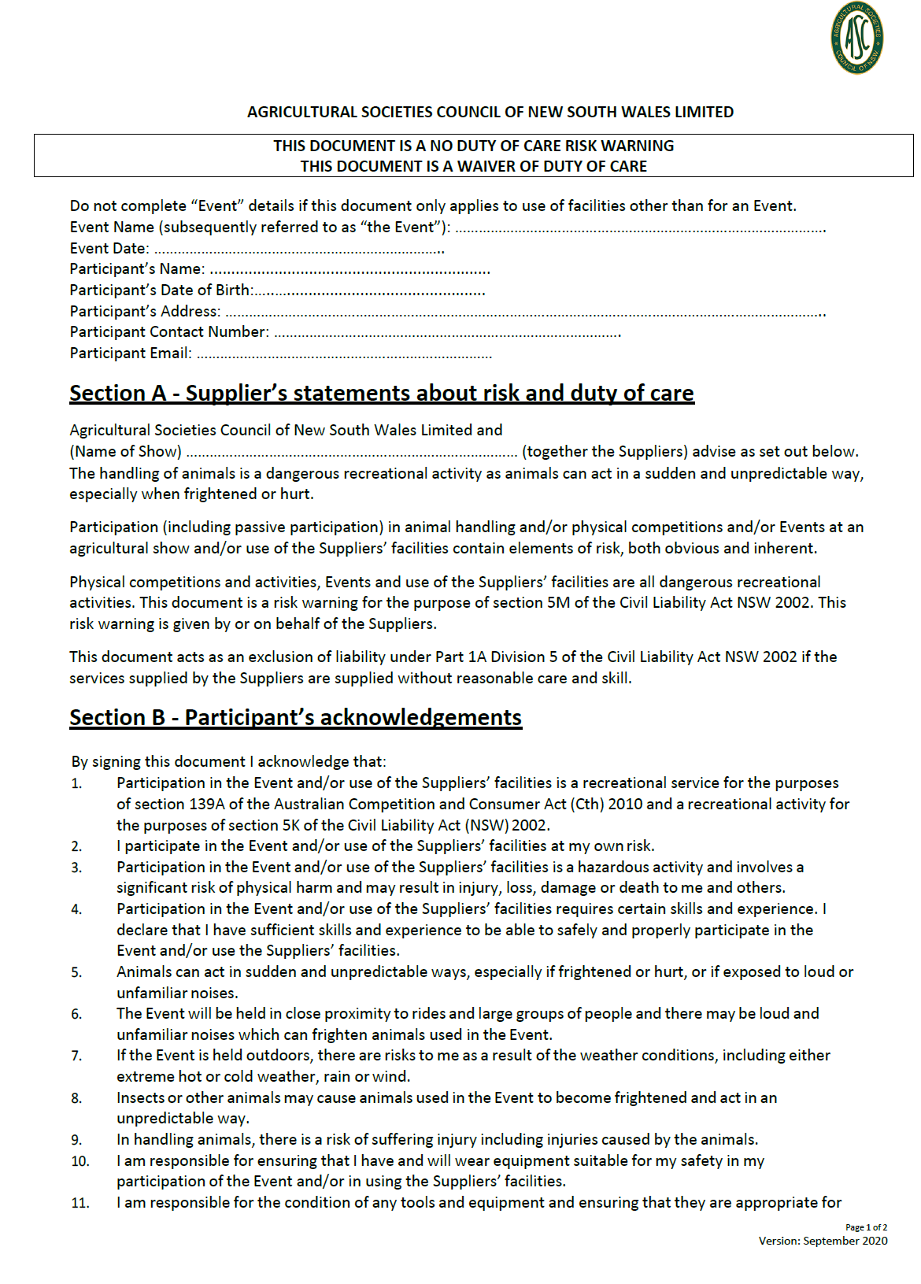

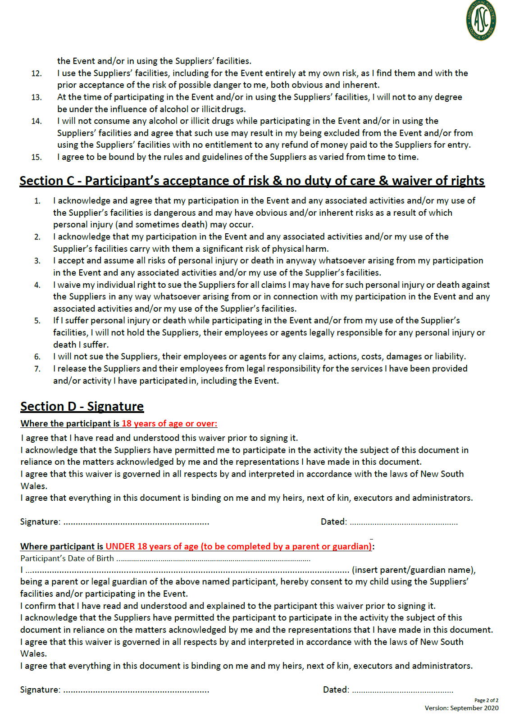

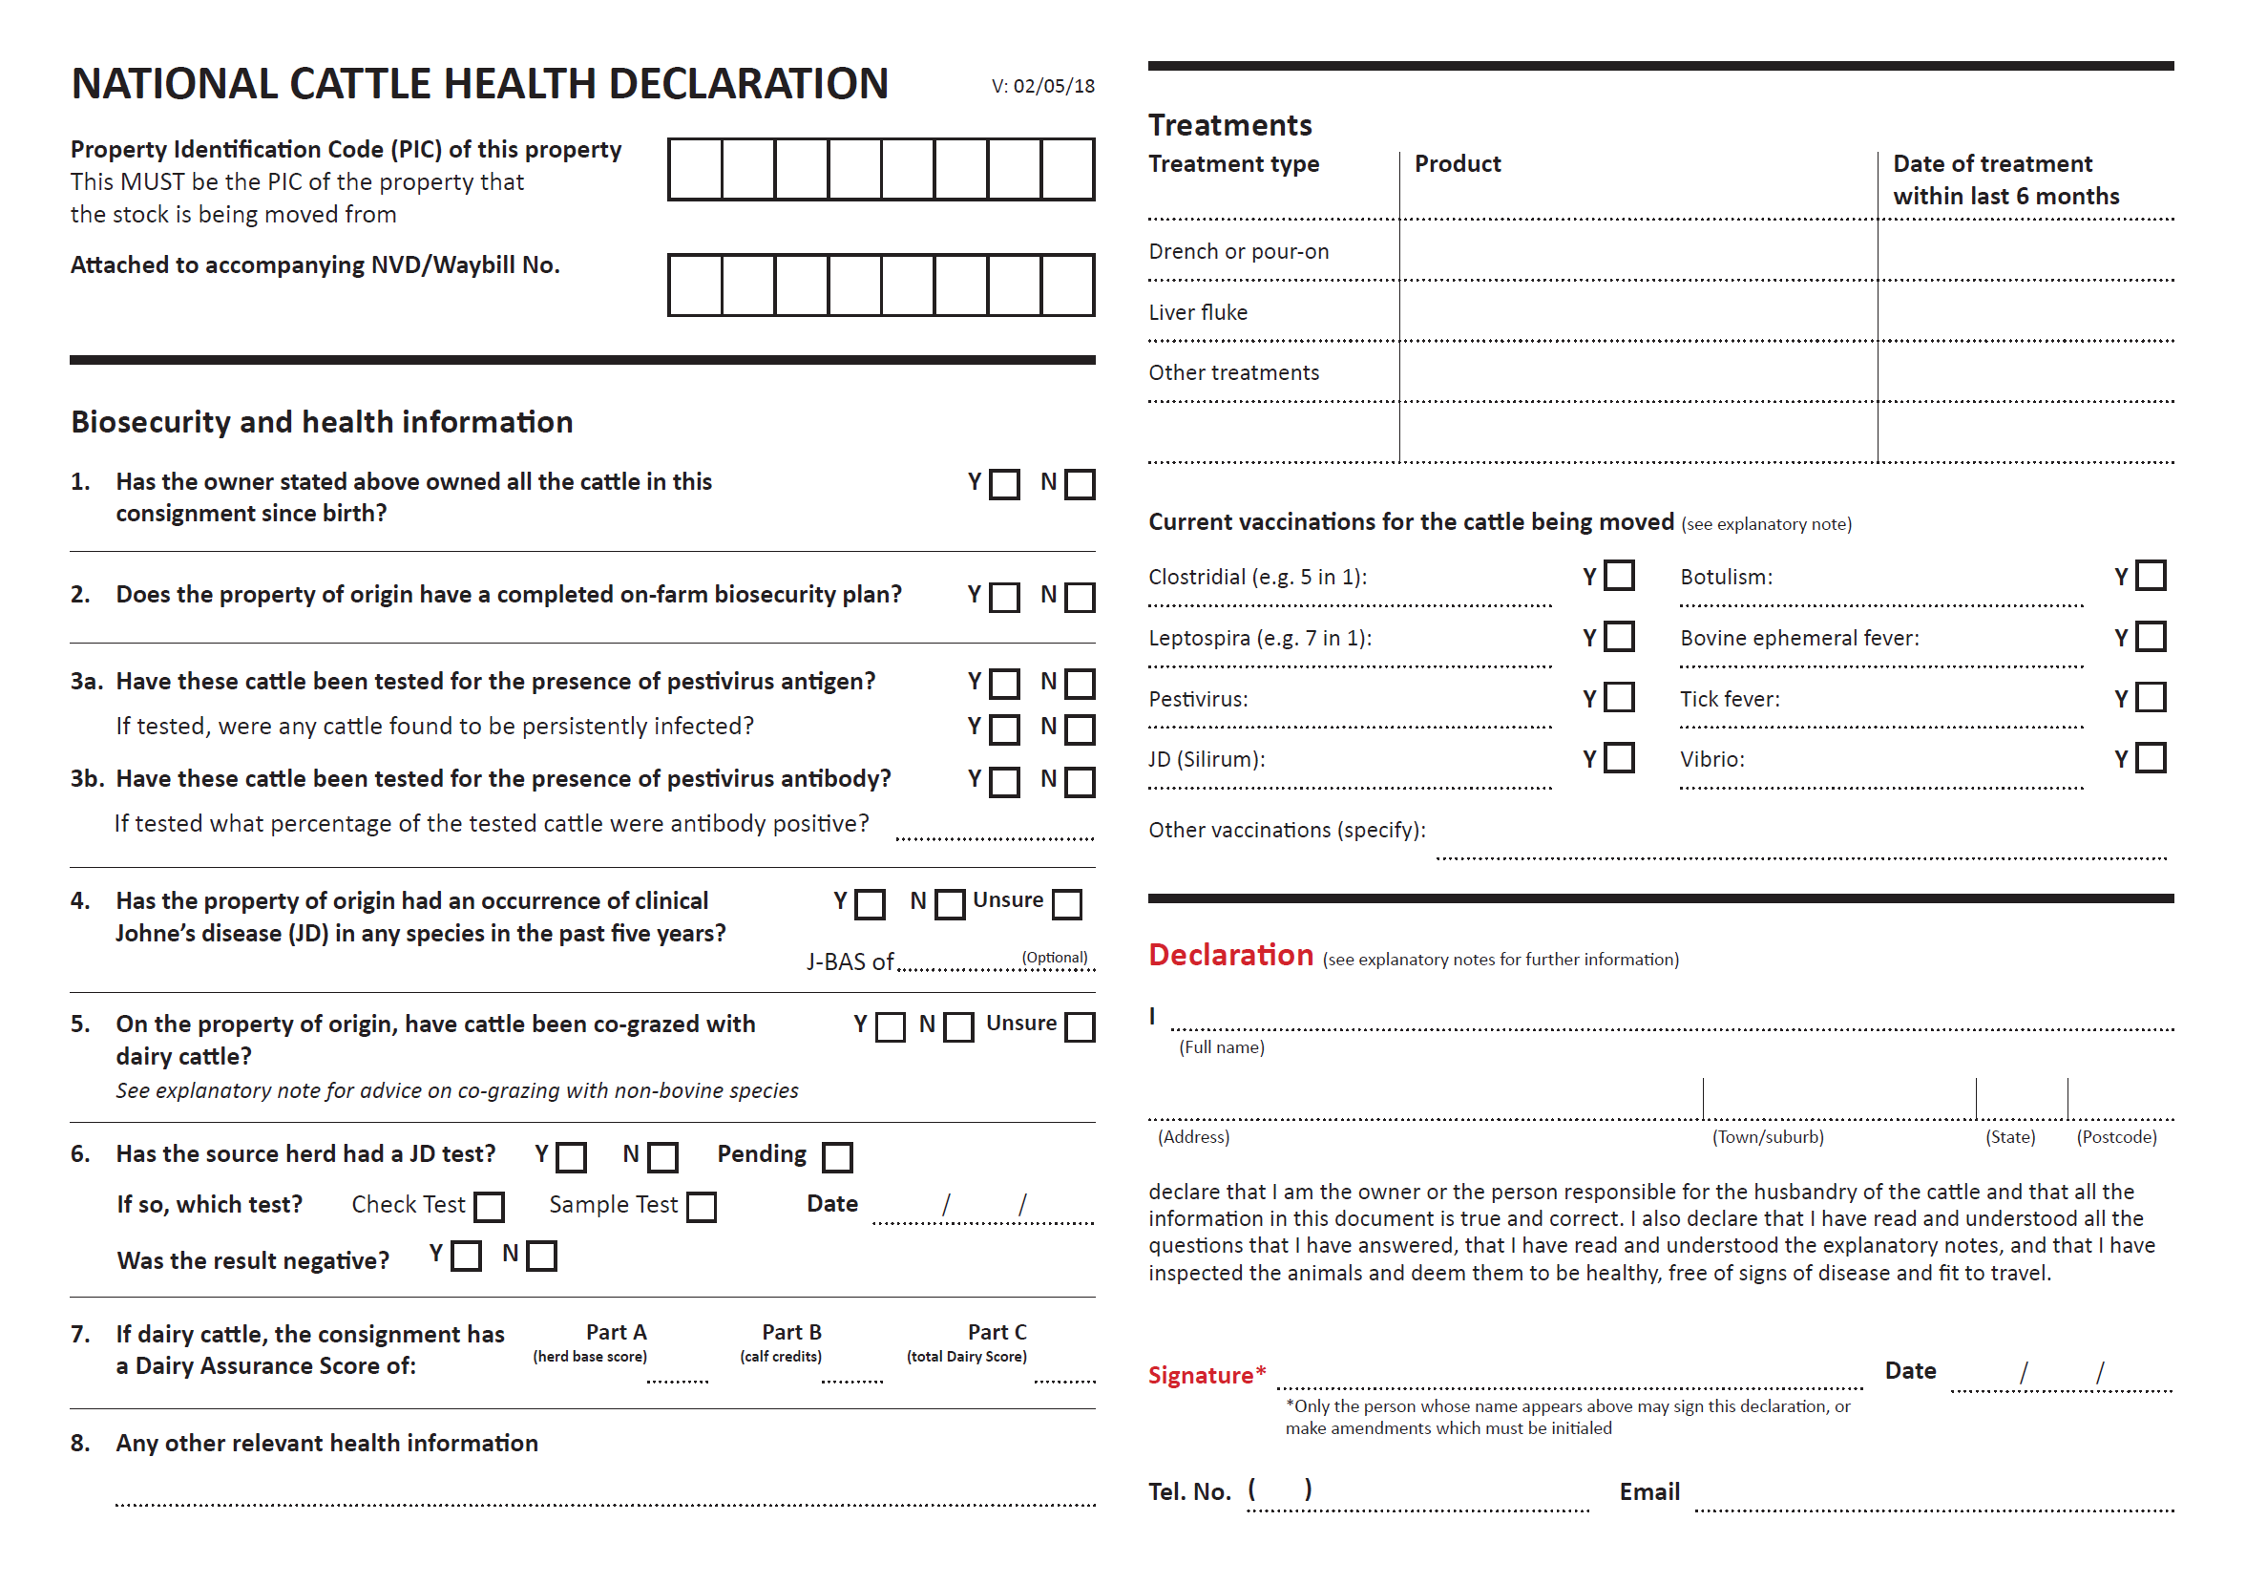

|  |  |
| --- | --- |
| ***Stud Name:*** | ***Breed:*** |
| ***PIC Number: (MUST BE COMPLETED)*** | ***Contact Name:*** |
| ***Address:*** | |
| ***Town:*** | ***Postcode:*** |
| ***Contact Number:*** | ***Email Address:*** |

